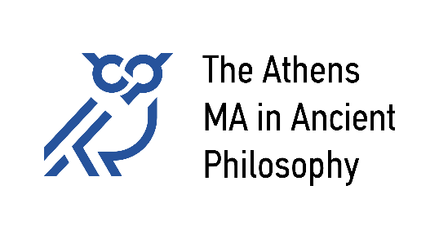
National and Kapodistrian University of Athens
Aristotle University of Thessaloniki
University of Patras
University of Crete

Regulation of the function of the Academic Advisor

January 2024

1. Aim
The Academic Advisors, in collaboration with the Student Support Services of the National and Kapodistrian University of Athens, offer advice and support to the students with a view of facilitating their integration in The Athens MA in Ancient Philosophy; they provide information to students on issues pertaining to their course of studies and their professional career; they pay particular attention to, and provide extra support for students facing personal, family or related difficulties that may affect their academic performance. Personal Tutors expend special effort in suggesting or providing solutions to crucial problems that might arise. However, they are not in a position to ensure in advance that all problems will be successfully resolved.

2. Mode of Operation
During the first week of the Winter Semester, the Program Director, after consultation with the academic members participating in the Program, assigns an Academic Advisor to each registered student. The Academic Advisor meets (in person, or online) each student, on a one-to-one basis, at least once during each academic semester, advises and supports the student on issues of course attendance, of choice among available courses, and of general academic prospects. The Academic Advisor bears the responsibility of monitoring the student’s academic progress. During the Summer Period, the Academic Advisor’s tasks are taken over by the Supervisor of the Master’s Thesis.

3. The Role of the Academic Advisor
The Academic Advisor is responsible for the following:
a) Support in facilitating the students’ smooth integration in the Program during their first Semester of studies.
b) The content of courses, the participation in workshops, the optimal use of the Deprtments’ infrastructure, evaluation methods for each course, encouragement to students for participating in progression tests, exercise sets, supportive tutoring where applicable, with the overall aim of enhancing a student’s understanding and of securing the successful completion of courses a student might find challenging.
c) The content of compulsory and of elective courses, informed choice of courses that will reduce the possibility of failure at the exams, so that the student’s choices are attuned to the student’s specific interests and academic capabilities.
d) Discussion of the exam results.
e) Choice of the topic of the Master’s Thesis.
f) Career Prospects (opportunities in the public or private sector, free-lance employment, working abroad).
g) Discussion of any issue that might create obstacles to the successful completion of the program of studies.
h) Issues about the Teaching Faculty.
i) Providing information about the University Student Support Service.
The Academic Advisor may also invite a student for a consultation meeting in case that is requested by a faculty member who assesses the student’s performance as problematic (continuing absences, suboptimal results in course tasks).
In exceptional circumstances, and following upon a well-grounded request by a student, a different Personal Student may be assigned to that student.

4. Protection of Personal Date
In fulfilling the tasks specified under sections 2 and 3 above, the student’s personal data and confidentiality are fully protected, as determined by law; the protection is in place both during and after the completion of the tasks of the Academic Advisor.

