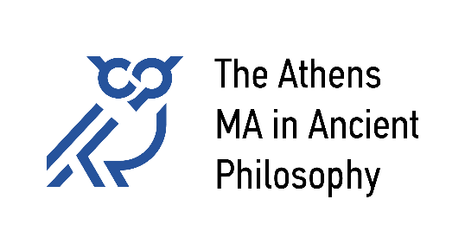
National and Kapodistrian University of Athens
Aristotle University of Thessaloniki
University of Patras
University of Crete

Student Complaints and Objections Policy Regulation

January 2024

1. Introduction
The adoption of a policy that will regulate Complaints and Objections by students of The Athens MA in Ancient Philosophy aims at securing the best possible operation of the MA in a way that exemplifies full respect towards all registered students.
Given the Program’s commitment to a student-centered academic experience, the prompt response to any complains or objections made by students is placed within a clear normative context, so as to ensure the fair treatment of all students, the improvement of the Program’s operation, as well as securing the Program’s reputation.
The following concerns all students enrolled in the Program, and it does not pertain to the purely academic aspects of the work of Faculty members.

2. Aim
The policy regulation regarding complaints and objections is addressed to all registered students of The Athens MA in Ancient Philosophy and aims at the resolution of a dispute or a problem, including:
α) disputes over issues of course of studies and attendance,
β) inappropriate conduct by a member of academic or administrative staff,
γ) inadequate guidance of students by a member of academic or administrative staff.

3. Field of Application
Students are expected to have studied the Study Guide and the general regulations governing the operation of the Postgraduate Program, so as to be aware of their rights and obligations. They are also required to communicate with their Personal Tutor for advice and support on issues related to their course of study. Students are able to make a complaint orally or in writing when an action by a member of staff, or by an academic committee, does not abide by:
a. the regulations of the Program
b. the code of deontology that applies to academic teaching and research
c. the rational employment of venues and related infrastructure
d. the protection of copyrights
e. appropriate conduct in a work place
f. the equality, and the measures taken against discrimination (racial, religious, gender, disability related), against bullying and sexual harassment.

4. Process applied
It is important to highlight that not any expression of dissatisfaction on behalf of a student may automatically initiate a formal process of addressing a complaint. Several of the problems that might be encountered by a a student might be possible to be resolved through an open and well-intended dialogue with the appropriate members of the academic or administrative staff.
The student ought first of all to present and explicate the problem to the appropriate member of the academic or administrative staff, with a view to attempting to find an appropriate solution that would be acceptable to all parties involved. In that process, the Personal Tutor may be involved so as to facilitate the securing an effective solution to the problem, based on informed consent. If the problem persists, and the student challenges the suggested solution, within 30 days of the problem’s arising, the student may proceed with a formal complaint, as described in the following section.

5. Formal Examination of Students’ Complaints
In case the problem fails to be resolved through the consensual process articulated in section 4, the student has the right to submit in writing a complaint to the Secretary, addressed to the Director of the Program, by filling in the appropriate form (see Appendix).
The Program Director takes all the necessary steps so as to ensure a fair and prompt examination of the complaint, and may:
a. Call a meeting of the board members of the Program so as to discuss the complaint. In case the complaint concerns a member of academic or administrative staff, that member has the right to be present at the meeting.
b. Ask the advice of experts, depending on the nature of the complaint.
c. Seek the support and consultation of the relevant officers of the Department of History and Philosophy or of the National and Kapodistrian University of Athens.
Within a reasonable period of no longer than two months, the student should receive in writing a formal update by the Program Director regarding the steps taken towards addressing the problem. If the solution offered by the Program Director is considered by the student unsatisfactory, the student may appeal to the General Board of the Department of the History and Philosophy of Science, fillin gin the same application form, and providing all details relevant to the problem and the deliberations that have taken place towards its resolution. The Board ought to examine the appeal and to reach a decision about the whole issue; the Board’s decision counts as final.
Appendix
COMPLAINT FORM

To: The Secretary of The Athens MA in Ancient Philosophy

Date: ______________________ Protocol No: ___________

Full Name: ______________________________________________
Father’s Name: ___________________ ID/Passport No: ______________________
Student’s Registration No: ___________________ Semester of Studies: ___________________
Address: _________________________________________________________
Phone No: ___________________________ E-mail ____________________
Subject-Matter of the Complaint: __________________________________________________________
Please describe briefly and clearly the problem you have encountered or the complaint you wish to make regarding the academic or administrative services provided in the Postgraduate Program.

I hereby declare that I consent to the use of my personal data for the purposes of the formal process pertaining to the examination of my complaint. Any documents related to the case are attached to the present form.

(Signature)

