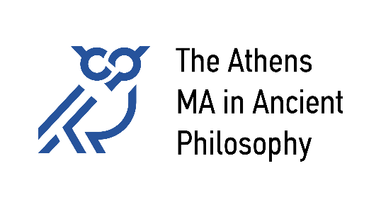

National and Kapodistrian University of Athens
Aristotle University of Thessaloniki
University of Patras
University of Crete

APPLICATION FORM
Academic Year 2024-25
Application Period: May 21 – June 30, 2024

Date of submission: ___ / __ / 2024
Application Nr.: ___ /2024

SURNAME, Name: | Father’s Name:
Place of Birth: | Date of Birth:
Citizenship(s): | ID or passport Nr.:
Email: | Telephone:

Degree(s):
Type | Dept. / University | Country | Conferral  Date | Grade / in a  scale of…
BA
...

I hereby submit my application for The Athens MA in Ancient Philosophy to athensma@phs.uoa.gr as a single PDF-file, followed by all other required application documents, in the following order:
- The present application form
- Curriculum Vitae
- Undergraduate degree, or confirmation of completion of studies
- Transcript of records
- Further university degrees and the relevant transcripts of records
- For non-native speakers: Certificate of English language proficiency at level C1 (or equivalent)
- ID or passport
- One reference letter
- Writing sample: A sample of scientific work prepared during previous studies (3000-6000 words), or an already published paper
- Letter of interest (200-400 words) stating the reasons for applying to The Athens MA in Ancient Philosophy. The letter should demonstrate familiarity with the field of Ancient Philosophy through the applicant’s previous studies or otherwise
Nr. 8 can be sent separately and directly to athensma@phs.uoa.gr, if the referee prefers to do so.

The applicant

[signature]

PDF files can be merged into a single file by using an app like Pdf-Sam.
Documents 1, 2 and 10 must be submitted in English. All other documents may also be submitted in Modern Greek, German, French, or Spanish, or translated into English.

