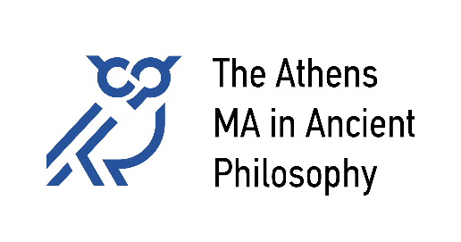

**National and Kapodistrian University of Athens**

University of Patras

University of Crete

**Academic Calendar 2025-26**

|  |  |  |
| --- | --- | --- |
|  | **Winter Semester** | **Spring Semester** |
| Expected arrival of students | 29 September |  |
| Classes start | 6 October | 16 February |
| Public Holidays  or no classes | 28 October (National Holiday) | 23 February (Clean Monday) 25 March (National Holiday) 1 May |
| Christmas/Easter break | 24 December – 6 January | 6-19 April |
| Classes end | 16 January | 29 May |
| Submission of Essays  or Exams Week | 2-6 February | 8-12 June |
|  |  |  |
| **Summer Term** (Thesis Preparation) |  | 15 June – 28 September  (no physical presence in Athens necessary) |
| Thesis Submission |  | 30 September* |
| Thesis Defense |  | 31 October* |
| **Graduation** |  | in November (online) |

* No extension is possible; if the deadline is missed, enrollment in a third semester will be necessary.