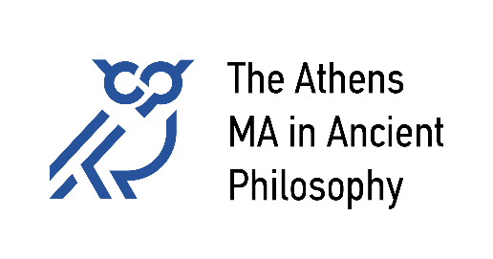

**National and Kapodistrian University of Athens**

University of Patras

University of Crete

**The Athens Colloquium in Ancient Philosophy**

The Athens Colloquium in Ancient Philosophy is a forum for scientific research and exchange on all topics and aspects of Ancient Philosophy, including its modern reception. It is organized by *The Athens MA in Ancient Philosophy*, in cooperation with the Research Centre for Greek Philosophy of the Academy of Athens and The Danish Institute at Athens.

The talks take place once a month, **on a Thursday at 7 pm**. The duration of the talks is between 30-40 minutes, followed by an extensive, free, focused, critical discussion that can last up to 60 minutes.

**2024-25:**   
Oct. 10 Paul Kalligas: “From Virtue to Happiness: A Neoplatonic Reversal”  
Nov. 14 Vassilis Karasmanis: “Plato's theory of recollection and his model of knowledge in the *Meno* and the *Republic*”   
Dec. 12 Pavlos Kontos: “Aristotle on the Unity of Virtue”  
Jan. 16 Giouli Korobili: “On the Intersection of Medicine, Astronomy and Meteorology at the Time of Orion”  
Feb. 20 Scarlett Kingsley: “Theorizing Oligarchy and the Revolution of the Four Hundred”  
Mar. 20 Pantelis Bassakos: “The art of judgment”   
Mar. 27 Phillip Mitsis: “Plato on Why Philosophers Must Nourish Hate”   
May 15 Federico Maria Petrucci: “The Philosophical Outlook of the *Critias*”