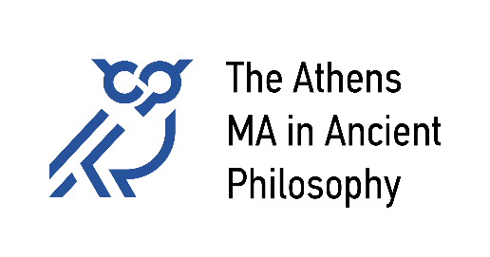

**National and Kapodistrian University of Athens**

University of Patras

University of Crete

**Courses Offered in 2024-25**

**Winter Semester:**

[**102. Plato**](https://athensma.phs.uoa.gr/fileadmin/depts/phs.uoa.gr/athensma/uploads/102a.docx)Georgia Sermamoglou-Soulmaidi  
[sermamo@upatras.gr](mailto:sermamo@upatras.gr)

[**103. Aristotle**](https://athensma.phs.uoa.gr/fileadmin/depts/phs.uoa.gr/athensma/uploads/103.docx)Stasinos Stavrianeas  
[sstavr@eap.gr](mailto:sstavr@eap.gr)

[**104. Hellenistic Philosophy**](https://athensma.phs.uoa.gr/fileadmin/depts/phs.uoa.gr/athensma/uploads/104.docx)Katerina Ierodiakonou & Ioanna Tigani  
[ierokaterina@phs.uoa.gr](mailto:ierokaterina@phs.uoa.gr),[annati@phs.uoa.gr](mailto:annati@phs.uoa.gr)

[**109. Topics in Ancient Philosophy**](https://athensma.phs.uoa.gr/fileadmin/depts/phs.uoa.gr/athensma/uploads/109a.docx)Eleni Kaklamanou  
[kaklamanel@uoc.gr](mailto:kaklamanel@uoc.gr)

**Spring Semester:**

[**101. Early Greek Philosophy**](https://athensma.phs.uoa.gr/fileadmin/depts/phs.uoa.gr/athensma/uploads/101.docx)Stavros Kouloumentas & Panagiotis Thanassas   
[skouloumentas@gmail.com](mailto:skouloumentas@gmail.com)

[**102. Plato**](https://athensma.phs.uoa.gr/fileadmin/depts/phs.uoa.gr/athensma/uploads/102b.docx)Chloe Balla & Federico Maria Petrucci  
[balla@uoc.gr](mailto:balla@uoc.gr); [federicomaria.petrucci@unito.it](mailto:federicomaria.petrucci@unito.it)

[**105. Philosophy of Late Antiquity**](https://athensma.phs.uoa.gr/fileadmin/depts/phs.uoa.gr/athensma/uploads/105.docx)George Karamanolis  
[george.karamanolis@univie.ac.at](mailto:george.karamanolis@univie.ac.at)

[**109. Topics in Ancient Philosophy**](https://athensma.phs.uoa.gr/fileadmin/depts/phs.uoa.gr/athensma/uploads/109b.docx)Stasinos Stavrianeas  
[sstavr@eap.gr](mailto:sstavr@eap.gr)