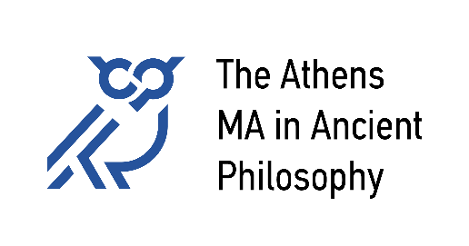
National and Kapodistrian University of Athens
University of Patras
University of Crete

Courses Offered in 2025-26

Winter Semester:
102. Plato
Eleni Kaklamanou, kaklamanel@uoc.gr
103a. Aristotle
Stasinos Stavrianeas, sstavr@eap.gr
103b. Aristotle
George Karamanolis, george.karamanolis@univie.ac.at
104. Hellenistic Philosophy
Katerina Ierodiakonou & Ioanna Tigani, ierokaterina@phs.uoa.gr, annati@phs.uoa.gr
Course in Ancient Greek (optional, without ECTS)
Vasiliki Kousoulini, kousoulini@upatras.gr
Spring Semester:
101. Early Greek Philosophy
Spyros Rangos, rangos@upatras.gr
105. Philosophy of Late Antiquity
Pantelis Golitsis, pgolitsis@edlit.auth.gr
107. Ancient Science and Philosophy
Michalis Sialaros & Petros Bouras-Vallianatos, msialaros@phs.uoa.gr, pbourasval@phs.uoa.gr
109. Topics in Ancient Philosophy
Chloe Balla, balla@uoc.gr
Course in Ancient Greek (optional, without ECTS)
Vasiliki Kousoulini, kousoulini@upatras.gr

