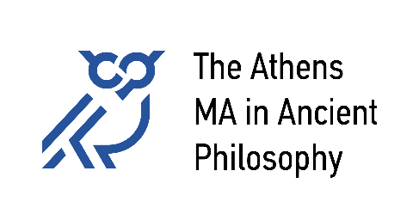

Course Schedule 2023-24

Winter Semester:
Courses will be taught at the Elli Lambridi Philosophical Library (9 Ypsilantou Str.).

 | Mo | Tu | We | Th | Fr
9-12
12-15
15-18 |  |  |  | IV. Hellenistic Philosophy Ierodiakonou/Tigani/Tsouna | ΙΙ. Plato Sermamoglou
18-21 |  |  | III. Aristotle Golitsis | 19.00, once a month: The Athens Colloquium in Ancient Philosophy

Spring Semester:

 | Mo | Tu | We | Th | Fr
9-12 |  |  |  |  | V. Philosophy of Late Antiquity  Karamanolis
12-15 |  |  | Ι. Early Greek Philosophy  Kouloumentas | IX. Topics in Ancient Philosophy  Balla
15-18
18-21 | VII. Ancient Science and Philosophy  Bouras-Vallianatos & Sialaros |  |  | 19.00, once a month:  The Athens Colloquium  in Ancient Philosophy

