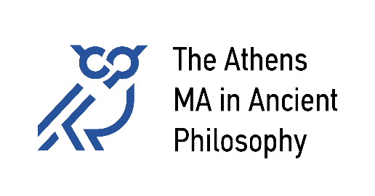

**National and Kapodistrian University of Athens**

University of Patras

University of Crete

**Course Schedule 2025-26**

**Winter Semester:**

|  |  |  |  |  |  |
| --- | --- | --- | --- | --- | --- |
|  | **Mo** | **Tu** | **We** | **Th** | **Fr** |
| **9-12** |  |  |  |  | **103. Aristotle** Karamanolis |
| **12-15** |  |  |  | **102. Plato**  Kaklamanou |  |
| **15-18** | **Ancient Greek (Intermediate)**  Kousoulini | **104. Hellenistic Philosophy** Ierodiakonou & Tigani [15.00-19.00] |  |  |  |
| **18-21** | **103. Aristotle** Stavrianeas |  | 19.00, once a month:  ***The Athens Colloquium in Ancient Philosophy*** |  |

**Spring Semester:**

|  |  |  |  |  |  |
| --- | --- | --- | --- | --- | --- |
|  | **Mo** | **Tu** | **We** | **Th** | **Fr** |
| **12-15** |  | **107. Ancient Science and Philosophy**  Bouras-Vallianatos & Sialaros |  | **109. Topics in Ancient Philosophy** Balla |  |
| **15-18** | **101. Early Greek Philosophy**  Rangos |  |  |  |  |
| **18-21** |  |  | **105. Philosophy of Late Antiquity** Golitsis | 19.00, once a month:  ***The Athens Colloquium***  ***in Ancient Philosophy*** |  |

Courses take place in the New Building of the Department of History and Philosophy of Science.

<https://maps.app.goo.gl/3zrZ7u5gHrv64AYs5>