2023-24

Students Enrolled

 | SURNAME, Name | Nationality | Email | Topic of Master’s Thesis | Supervisor
 | CHEN, BingBing | China | chenbb001001@163.com | Nous in Nicomachean Ethics | Kontos
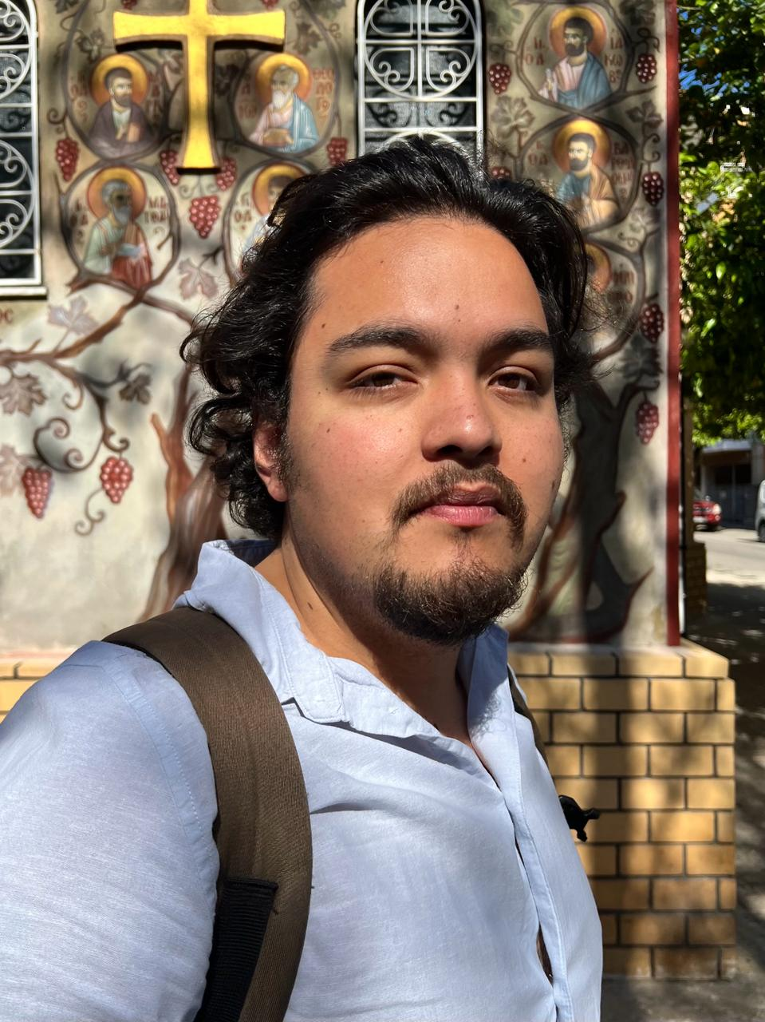 | CONTRERAS MORAN, Francisco | Mexico, Spain | francisco.contreras.moran@gmail.com, | On the Moral Psychology of Dialectic in Plato's Philebus | Thanassas
 | IVANOVA, Evgeniya | Uzbekistan | e.ivanova@phs.uoa.gr | The Role of Age and its Epistemic Significance in Plato’s Laches and Euthydemus | Sermamoglou
 | JOHNSON,  Asher | USA | apascaljohnson22@gmail.com | Plotinian Notions of Freedom and Civic Duty | Golitsis
 | LACERDA COSTA, Henrique | Brazil | henriquelaccosta@gmail.com | Nobility in the Iliad and Heraclitus? Between mortals and immortals | Rangos
 | MAVROUDIS, Konstantinos | Greece | kostasmavroudis12345@gmail.com | The Ontological Aspects of Physis, Logos, Aletheia in early Greek Thought | Thanassas
 | PANG,  Yawen | China | pangyawen@ruc.edu.cn | Emotions and Actions in Early Stoics | Ierodiakonou
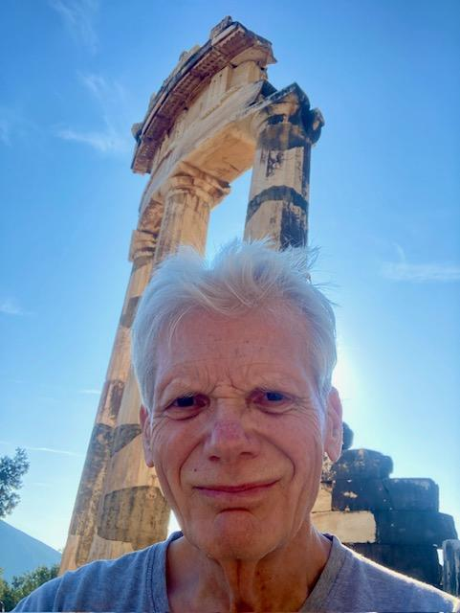 | SWANSON,  Todd | USA | archaeotraveler@gmail.com | On Socrates: Can Truth be Discovered through Duplicity? | Sermamoglou
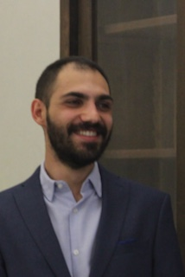 | TAMPONI,  Paolo | Italy | paolotamponi92@gmail.com | Asia and Europe in the Hippocratic Airs, Waters, Places. | Kouloumentas
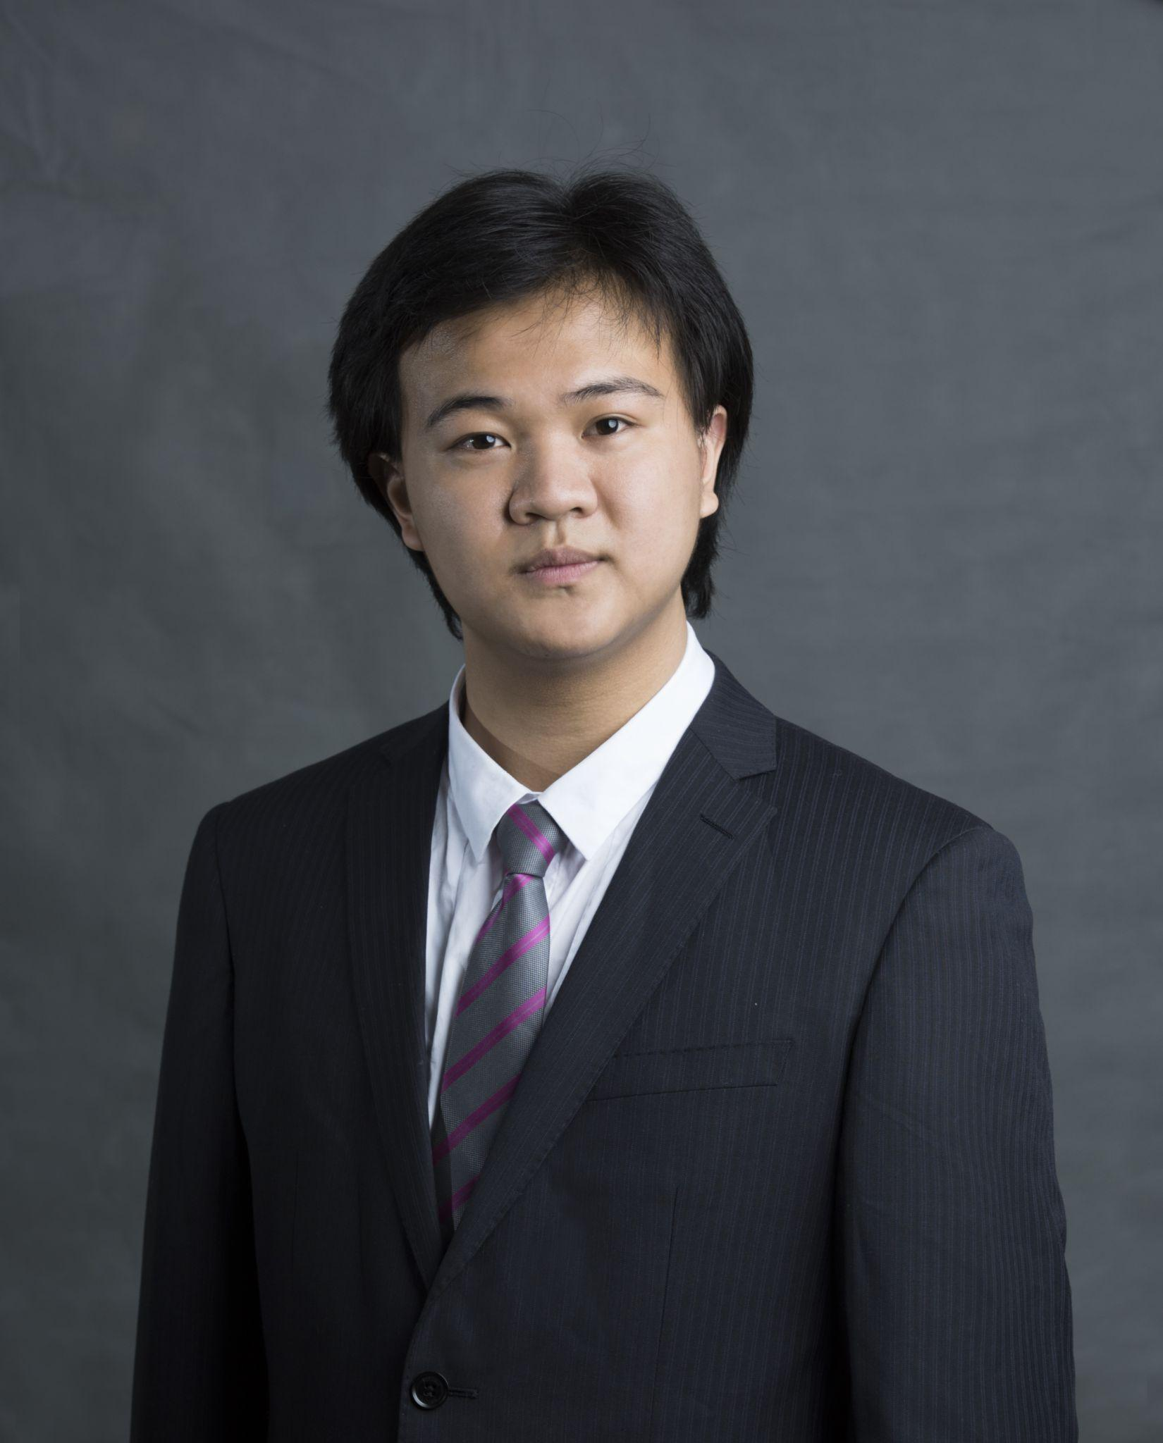 | XIONG,  Haowen | China | xiongjiujiu@phs.uoa.gr | Aristotle on Deformity (preliminary) | Stavrianeas
 | ZARAKOVITIS, Timotheos | Netherlands | t.zarakovitis@hotmail.com | Procession and Reversion between the One and Intellect in Plotinus and Proclus | Viltanioti
 | ZGURZYNSKI, Julia | USA | juliazgurzynski@gmail.com | Aristotle’s Deductive Principles in Prior Analytics | Ierodiakonou

