
National and Kapodistrian University of Athens
University of Patras
University of Crete

2025-26

Students Enrolled

 | SURNAME | Name | Email | NATIONALITY | Academic Advisor
 | CHOPRA | Supriya | supriyachopra009@gmail.com | INDIA | Thanassas
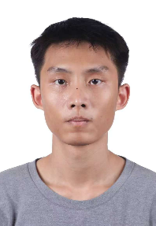 | FENG | Yilin | fengandy2002@gmail.com | CHINA | Tigani
 | FILIPPOU | Marina | marinafilippou14@gmail.com | GREECE | Golitsis
 | KAMPRIS | Loukas | lkabris2@gmail.com | GREECE | Kouloumentas
 | LEVINA | Olga | oflevina@gmail.com | RUSSIA | Balla
 | LIN | Ke | keketongxue@gmail.com | CHINA | Kontos
 | LIU | Jiankai | liujiankai@ruc.edu.cn | CHINA | Kaklamanou
 | LLOYD | Lalya | lloydlalya@gmail.com | UK | Karamanolis
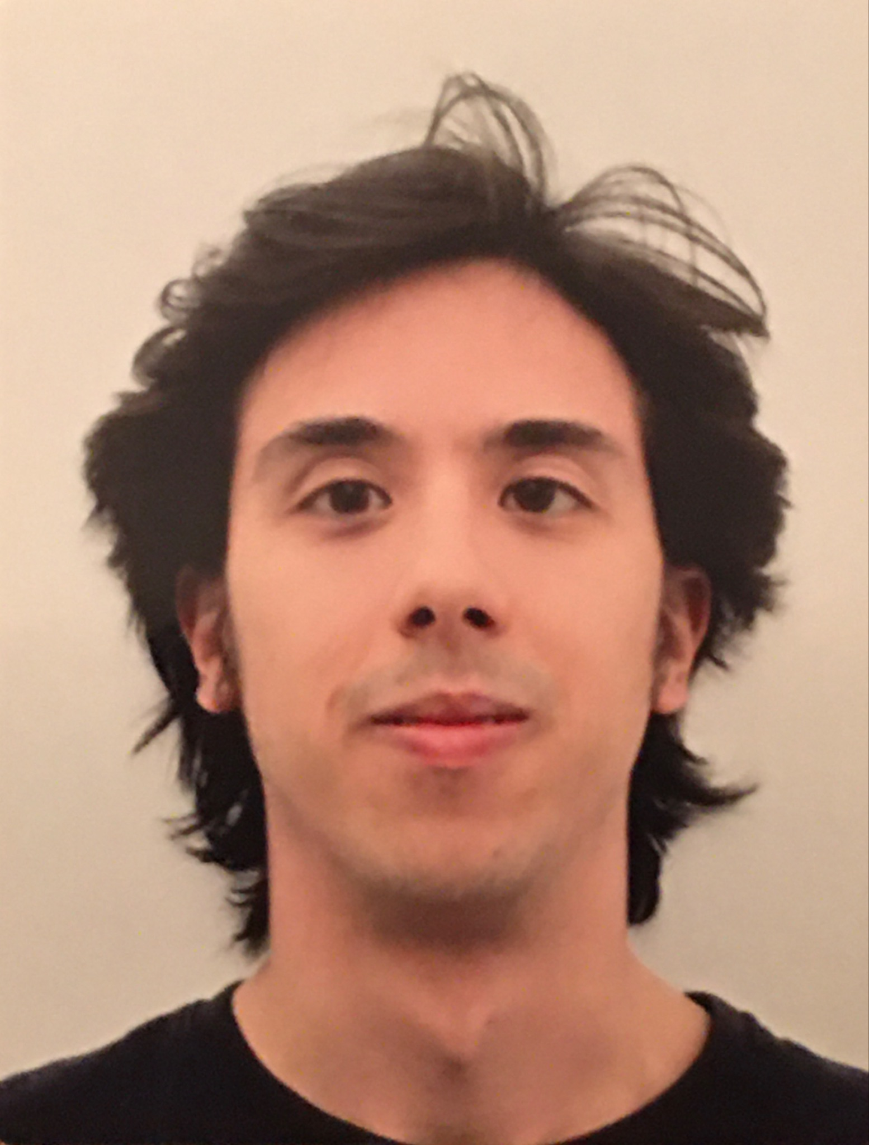 | MACALELLO | Alvise | alvisemac@gmail.com | ITALY | Ierodiakonou
 | RODRIGUEZ | Alonso | alonsojrodriguez1@gmail.com | USA | Karamanolis
 | RODRIGUEZ | Kellys Andreína | kellysandreina@gmail.com | VENEZUELA/  SPAIN | Thanassas
 | TUPOLA | Tintti | tintti.tupola@outlook.com | FINLAND | Viltanioti
 | WANG | Xing Hao | xhwang@phs.uoa.gr | SINGAPORE | Ierodiakonou
 | WANG | Shiyi | wsy1271@mail.bnu.edu.cn | CHINA | Stavrianeas

